ALBOURNE PARISH COUNCIL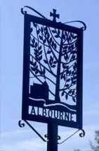

Invites you

To the Annual General

Meeting of the Parish

on **Tuesday, 6th May 2025**

**at 7.30 p.m. in the Village Hall**

_________________________________

The Agenda for the meeting will be published on   
the 24th April 2025, and the draft minutes of the May 2024 meeting will be posted up on the Parish Council’s website prior to this meeting (or will be available at the meeting itself).

We hope that you will be able to join us  
 for the meeting, as this is your chance to have your say, with Parish, District, and County Councillors present, on any issues  
 that concern or affect you!

Albourne Parish Council  
*Dated: 17th April 2025*