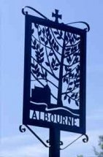
ALBOURNE PARISH COUNCIL
Invites you
To the Annual General
Meeting of the Parish
on Tuesday, 5th May 2026
at 7.30 p.m. in the Village Hall
_________________________________
The Agenda for the meeting will be published on
the 23rd April 2026, and the draft minutes of the May 2025 meeting will be posted up on the Parish Council’s website prior to this meeting (and will be available at the meeting itself).
We hope that you will be able to join us
for the meeting, as this is your chance to have your say, with Parish, District, and County Councillors present, on any issues
that concern or affect you!
Albourne Parish Council
Dated: 15th April 2026

