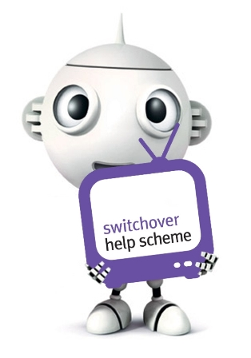
Help is at hand to switch to digital TV

TV is switching to digital all over the UK and if you don’t have digital TV by the time of switchover, you will lose your TV channels. This can seem a bit daunting but there is help available for anyone who is over 75 and/or is disabled.

The BBC-run Switchover Help Scheme offers practical help for older and disabled people to convert one TV set to digital, including installation of the easy-to-use equipment, a demonstration of how to use it and 12 months of aftercare service including a free helpline.

If you are eligible you will have been sent a Help Scheme letter and information pack through the post. Most eligible people will be asked to pay £40 towards the standard option whilst those who are eligible and on income related benefits will get it free. If you want the help, you need to apply by telephoning the Help Scheme or completing the form.

Doris who is 101 and partially sighted contacted the Help Scheme and was very impressed by the efficiency of the installer and how helpful he was. 'Peter was very tidy and put everything back as he found it. He was very patient as he showed me how to use the new remote control and I now also have the audio description facility as I can’t see the screen so well.’ Doris was very relieved to know that her TV was converted successfully as she relies on it for company.

The Switchover Help Scheme has helped hundreds of thousands of people to switch to digital. For more information, call 0800 40 85 900 or visit helpscheme.co.uk.

