ALBOURNE PARISH COUNCIL
An Ordinary Meeting of the Parish Council held on Monday 22nd February 2010 in Albourne Village Hall.
____________________________________________________________
Minutes
Present: Cllr Graham Stafford (Chairman), Cllr Michael Gratton (Chairman of Planning Committee),
Cllr Robert Dunckley, Cllr Gwyn Price, Cllr Lesley Ritchie and Cllr John Gooch.

238. Apologies for Absence
Cllr Jerry Butler, MSDC Sue Seward, WSCC Peter Griffiths and Clerk to the Council Jenny Hartley.
239. Declaration of Interest
Cllr Gratton (Planning).
240. Approval of Minutes
Proposed Cllr Price. Seconded Cllr Dunckley. All in favour.
241. Matters Arising from the Minutes
Cllr Price to inform Clerk of typing errors. Cllr Gooch informed member’s minute number 233 was
correct at the time of printing however would like the attached sheet included as an updated
appendix at the end of this document.
Cllr Price informed members the street light at the junction of Church Lane is still out.
242. To Receive Reports from
i. WSCC – Peter Griffiths – Sent apologies
ii. MSDC – Sue Seward – Sent apologies
243. Planning Liaison Committee
i. New Applications
10/00214/TCA Bounty Cottage - No objection
10/00342/TCA Hunters Cottage- No objection.
10/00347/LDC 2 Church Lane - No comments, other than we assume that the existing constraints regarding residential development on the site will remain.
10/00398/FUL Land off Trusslers Hill Lane, Albourne- APC strongly objects to this application.- The proposal does not meet the requirements of Local Plan policy R12 (specifically points 1 and 2). The building is very large relative to field size, and isolated (away from the field edge and entrance. The building, by dint of its size and location would be obtrusive and prominent in the landscape. NB - There are public footpaths ON and directly adjacent to the site. These run along three complete sides of the 10 acre paddock.

ii. Recent Decisions of the planning authority
Shaves Farm – Granted
Butts Cottage – Permission
Arden Grange – Refused
Daisy Fields – Granted, planting taking place.
244. Enforcement Update
The land at the corner of B2118 AND B2116 (known as Orr). It was agreed that Cllr Gratton would follow up with John Arnold to ascertain precise nature of the "legal" question, and to confirm that he has actually visited the site.
Land adjacent to Coombe Hill on B2118 (Sand School). Agreed that the Clerk will report to Environment Health for possible contravention of light pollution rules. Agreed that MG will contact John Arnold to ascertain precise detail of (any) planning application relating to the sand school. Also to challenge his claim that lighting is temporary.
Cllr Stafford asked for an update regarding the Albourne Equestrian Centre and the retrospective planning application, and also it was noted there had been planting taking place at Highcross.
8.20pm meeting closed for member of the public to speak.
Member of the public stated he had applied through the correct planning channels for lighting at a Sand School and been refused yet this had been accepted at Coombe Hill.
8.24pm meeting reconvened.
Scrap and vehicles at Pottersfield (wind turbine). Clerk to chase Stephen King at MSDC for a response.
245. Chairman’s Report
Cllr Stafford reported the Salt bins from Church Lane had been stolen. All members voted in favour
costing 3 replacement salt bins for the village. Clerk to pursue.
County Council are considering amalgamating all 3 CLC’s together – MS/HH & E.Grinstead. All
members agreed that a letter should be written objecting to this proposal.
246. Village Hall Chairman’s Report
Cllr Butler (VH Chair not present). Next Spring Craft Fair - 6th March 2010.
VH lease update: Cllr Price brought the meeting up to date on discussions over the new lease for
the village hall. David Waite had raised various issues about ensuring that the interests of the charity
were properly taken account of where they might diverge from those of the Parish Council. There
were still various loose ends concerning the way the new lease would deal with the proposed school
footpath and OGP would be taking these up with David Waite.
247. Finance and administration report
Clerk not present for full report. Cllr Stafford informed members of the precept figure for
2010/2011 set at £14,500. The Clerk has requested the Budget/ precept be an agenda item for
the November meeting in 2010 so as to allow time for discussion as MSDC need the responses for
Precept in by 3rd week of January each year which given the dates of the APC meetings would make
this deadline tight to achieve. The Clerk would like it to be noted that the ‘rush’ for the return of
the precept was hampered by her having undergone heart surgery, cancellation of the January PC
meeting, and the initial emails relating to the precept chase up, having gone to the wrong email
address by MSDC. This has now been corrected.
A meeting will need to be arranged once Cllr Price returns from holiday with the trustees of the VH
to discuss the VH lease. Try to schedule at the next PC meeting.
248. Additional Items since Preparation of the agenda
Cllr Gooch – See information attached regarding Church. Please to see the speed sign is going
ahead near to Western Cottages.
249. Councillors Exchange of Information
Cllr Ritchie – Street Light at the top of Barley Croft – on all the time. Clerk to deal.
British Telecom is calling all addresses in Barleycroft ‘Firbanks’. This is due to the property located
at No1, re-naming itself Firbanks. Clerk to write to BT.
Potholes – Gunners Hill – Westbound, Opposite Gunners Cottage.
West of Western Cottages on the B2116
At the top of the school drive (school entrance)
South Entrance to Barley Croft
Drains dropping in The Street, Hunters Mead – near the VH. The drain Covers have dropped down
creating a gap.
Clerk to report the above to WSCC.
Cllr Gooch – Fly Tipping at the West End of Reeds Lane. Builders Rubbish.
Cllr Gratton – Prepare a list for the Rangers in September so we are prepared. Cllr Gratton has
been contacted by the owners of Bounty Cottage, so we can expect an application soon.
250. Date of Next meeting – Monday 15th March 2010 at 7:30pm
Meeting Closed at 9:25pm

See Appendix

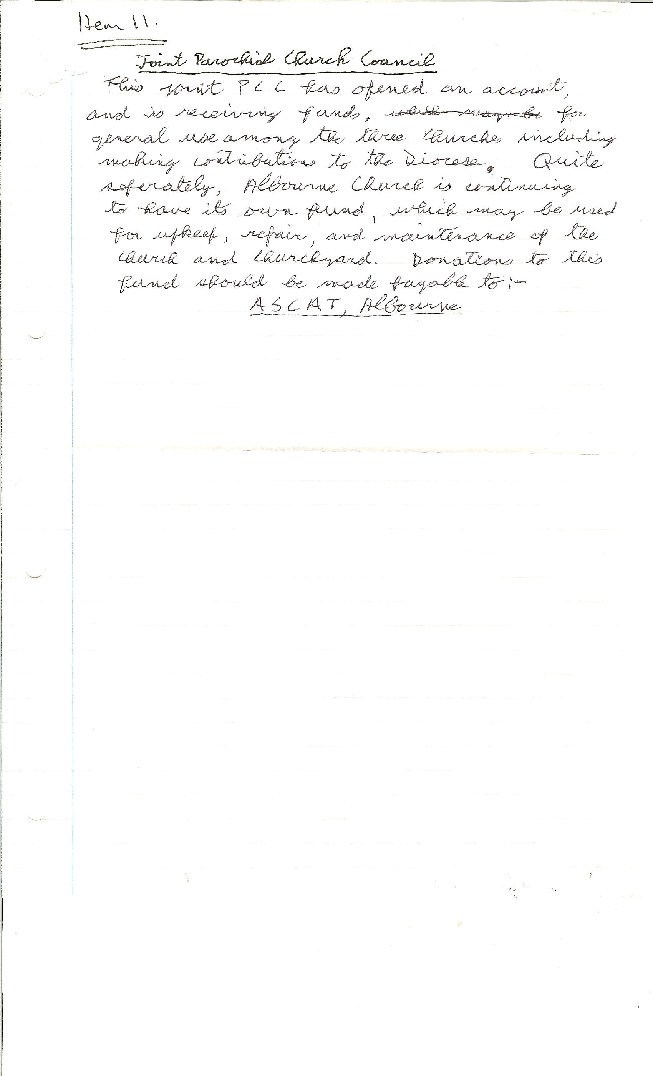

Signed:__________________________________________________________________

Date:_____________________________________

