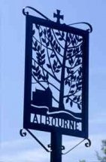
NOTICE OF VACANCY
IN THE OFFICE OF COUNCILLOR

ALBOURNE PARISH COUNCIL

NOTICE IS HEREBY GIVEN THAT

A second casual vacancy exists in the Office of Councillor for Albourne Parish Council.

A by-election to fill the vacancy will be held if, within 14 days (excluding Saturdays, Sundays and Bank Holidays), TEN electors of the electoral area give notice in writing claiming such an election to the Proper Officer.

The Proper Officer is: Kathryn Hall, Returning Officer,
Mid Sussex District Council, Oaklands Road, Oaklands,
Haywards Heath, West Sussex, RH16 1SS
Email: elections@midsussex.gov.uk

If no such notice is given the Parish Council shall fill the vacancy by co-option.

Dated: 6th May 2026

Signed: Iain McLean
Parish Clerk
Address and contact details of Parish Clerk:
Iain McLean, c/o Albourne Village Hall, The Street, Albourne, West Sussex, BN6 9DG
T: 07702190707 E: clerk@albourne-pc.gov.uk

